Server
#include <stdio.h>
#include <stdlib.h>
#include <winsock2.h>

#pragma comment(lib,"ws2_32.lib")

int isPrime(int n) {
if (n <= 1) return 0;
for (int i = 2; i * i <= n; i++)
if (n % i == 0) return 0;
return 1;
}

int gcd(int a, int b) {
return b == 0 ? a : gcd(b, a % b);
}

int modInverse(int e, int phi) {
int t = 0, newt = 1;
int r = phi, newr = e;
int q, temp;

while (newr != 0) {
q = r / newr;

temp = t;
t = newt;
newt = temp - q * newt;

temp = r;
r = newr;
newr = temp - q * newr;
}

if (r > 1) return -1;
if (t < 0) t += phi;
return t;
}

long long modExp(long long base, long long exp, long long mod) {
long long result = 1;
while (exp > 0) {
if (exp % 2 == 1)
result = (result * base) % mod;
base = (base * base) % mod;
exp /= 2;
}
return result;
}

int main() {
WSADATA wsa;
SOCKET serverSock, clientSock;
struct sockaddr_in serverAddr, clientAddr;
int addrLen = sizeof(clientAddr);

int p, q, e, d, n, phi;
long long cipher, message;

printf("Enter prime p: ");
scanf("%d", &p);
printf("Enter prime q: ");
scanf("%d", &q);

if (!isPrime(p) || !isPrime(q)) {
printf("Invalid prime numbers\n");
return 0;
}

n = p * q;
phi = (p - 1) * (q - 1);

printf("Enter public exponent e: ");
scanf("%d", &e);

if (e <= 1 || e >= phi || gcd(e, phi) != 1) {
printf("Invalid value of e\n");
return 0;
}

d = modInverse(e, phi);
if (d == -1) {
printf("Modular inverse not found\n");
return 0;
}

printf("\nPublic Key (e,n) = (%d,%d)\n", e, n);
printf("Private Key (d,n) = (%d,%d)\n", d, n);

WSAStartup(MAKEWORD(2,2), &wsa);

serverSock = socket(AF_INET, SOCK_STREAM, 0);

serverAddr.sin_family = AF_INET;
serverAddr.sin_port = htons(8080);
serverAddr.sin_addr.s_addr = INADDR_ANY;

bind(serverSock, (struct sockaddr*)&serverAddr, sizeof(serverAddr));
listen(serverSock, 1);

printf("\nServer waiting for client...\n");

clientSock = accept(serverSock, (struct sockaddr*)&clientAddr, &addrLen);

recv(clientSock, (char*)&cipher, sizeof(cipher), 0);
printf("Ciphertext received: %lld\n", cipher);

message = modExp(cipher, d, n);
printf("Decrypted message: %lld\n", message);

closesocket(clientSock);
closesocket(serverSock);
WSACleanup();

return 0;
}

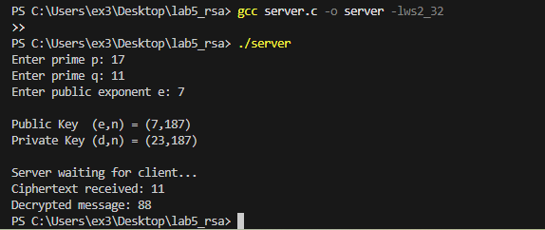
Client
#include <stdio.h>
#include <stdlib.h>
#include <winsock2.h>

#pragma comment(lib,"ws2_32.lib")

long long modExp(long long base, long long exp, long long mod) {
long long result = 1;
while (exp > 0) {
if (exp % 2 == 1)
result = (result * base) % mod;
base = (base * base) % mod;
exp /= 2;
}
return result;
}

int main() {
WSADATA wsa;
SOCKET sock;
struct sockaddr_in serverAddr;

int e, n;
long long message, cipher;

printf("Enter public key e: ");
scanf("%d", &e);
printf("Enter modulus n: ");
scanf("%d", &n);

printf("Enter message: ");
scanf("%lld", &message);

if (message >= n) {
printf("Message must be less than n\n");
return 0;
}

cipher = modExp(message, e, n);
printf("Encrypted message: %lld\n", cipher);

WSAStartup(MAKEWORD(2,2), &wsa);

sock = socket(AF_INET, SOCK_STREAM, 0);

serverAddr.sin_family = AF_INET;
serverAddr.sin_port = htons(8080);
serverAddr.sin_addr.s_addr = inet_addr("127.0.0.1");

connect(sock, (struct sockaddr*)&serverAddr, sizeof(serverAddr));
send(sock, (char*)&cipher, sizeof(cipher), 0);

closesocket(sock);
WSACleanup();

return 0;
}

